**LAB 1: CLOUD COMPUTING IN DAILY LIFE EXERCISE_TRIP PLANNER**

**Student Name: Joseph Mawolo Kpoto**

**Instructor Name: Dr, John C. Chan**

**Course: CS519 (Introduction to Cloud Computing)**

**Lab Due Date: January 13, 2018**

**BACKGROUND:**

In this lab, we examined a common application (Trip Planner), and explored how cloud computing is driving its functionality behind the scenes.

**OBJECTIVE:**

Upon completion of the lab, we are able to:

* Appreciate Cloud Computing in our daily life.

**TOOLS, MATERIALS, AND SOFTWARE:**

The following software and utilities were used to complete this lab

* iPhone 6S
* Personal Computer (Laptop)
* The Internet

**PROCEDURE:**

**PART 1: DOWNLOADING AND USING APP ON PHONE**

On my iPhone, the “Applications Store” was launched as shown in figure 1.0.0 below.

Fig: 1.0.0: Depicts a window displaying the App store being launched/opened

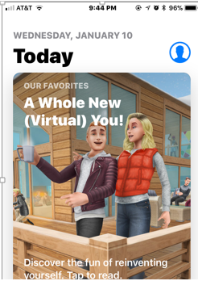

After the launching of the “App Store” the key word “King County Trip Planner” was typed in the search bar as shown in Fig 1.0.1 below. I live in North Seattle.

Fig: 1.0.1: Depicts a window displaying the key word “King County Trip Planner” typed



At this point, many other “App” popped up but the one that was interest was the “Puget Sound Trip Planner”. As is done in downloading other Apps, I clicked on “GET” as shown in figure 1.0.2 below.

Fig: 1.0.2: Depicts a window displaying “GET” clicked to download App.

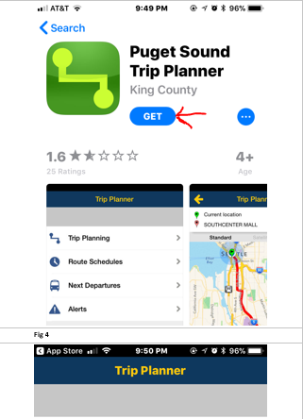

The “Puget Sound Trip Planner” App was downloaded successfully on my iPhone as shown in Fig 1.0.3 below.

Fig: 1.0.3: Depicts a window displaying the “Puget Sound Trip Planner” App downloaded successfully

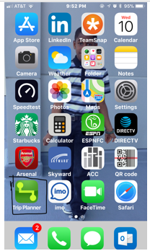

I then launched the App to plan a trip from home to my workplace by tapping “Trip Planning”.

Fig: 1.0.4: Depicts a window displaying the “Trip Planning” link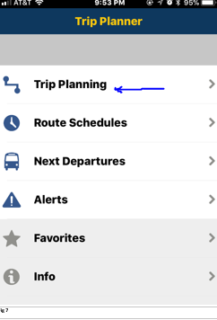

From the setting, I then chose my options for the planned trip. Such option included: “Sort Result By”, “Transportation Modes”…. The picture below shows the details of my selections (see checked options).

Fig: 1.0.5: Depicts a window displaying the “Trip Planning” options

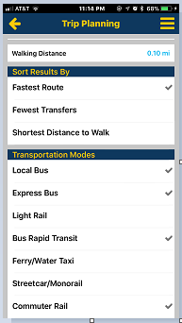

After populating/setting my departure time and date, I then clicked “Get Trip Plan” link.

Athis point, I noticed that this App delivers many useful information for the daily commuters. Such as Routes, Departure time, Arrival time, Walking distance, fare and many more. Figure 10.0.6 shows the details.

Fig: 1.0.6: Depicts a window displaying the useful information for the daily commuters 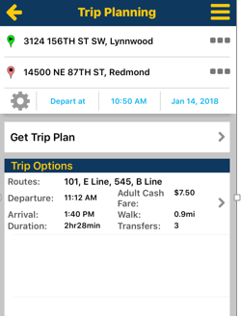

**PART 2: CHALLENGE QUESTION AND ANSWERS**

Here, we explored how much of the imformation provided by this tool (“Puget Sound Trip Planner”) are likely implemented on the cloud computing environment (vs on a hand-held phone).

1. **The Street map database**: Yes, this can be implemented in a cloud enviroment. For example, OpenStreetMap (OSM) is a free, editable map of the world. As new users join, via the Internet, the open mapping community, more and more valuable data is being added to OpenStreetMap.
2. **The Bus/Transit Route information**. Yes, this can be implemented in cloud enviroment. For example, North American schools use Versatrans Routing & Planning to create efficient, sensible bus routes. Versatrans Routing & Planning is also available as a cloud-based solution.
3. **The arrival/departure timing information**: This can be implemented in the cloud environment as is already done at airports/road traffic. This would be considered under location-Based services. Location-Based Services can estimate time of approach, arrival, departure, duration of stop, current traffic information, and etc.
4. **The computing, the processing of the raw data, before final results are seen by you:** These are scripts or program that makes cloud computing works. These are not stand alone. So I would think this is handled by hand-held device.
5. **The collection of your location/GPS information**: Location-based services provide information specific to a location using the latest positioning technologies and are a key part of the mobile web services suite. Yes, this can be implmented in the the cloud enviroment.

**PART 3: BONUS EXERCISE**

1. **GPS download/installation on Laptop**

GPS technology helps people find locations, get turn-by-turn driving directions, plan trips and follow along on maps as they travel. Installing GPS on a laptop offers certain features that can't be found in a small standalone GPS unit. The large-screen size makes it easy to follow along with directions, and GPS receivers can be used in conjunction with a variety of mapping software applications.

Below are the steps in downloading GPS on a PC:

1. Install the mapping software by inserting the installation disc into the laptop and following the setup wizard instructions. Mapping software and GPS receivers are available bundled together. If you already have a receiver, you can purchase mapping software separately or download a freeware mapping program.
2. Insert the installation disc that came with your GPS receiver into the laptop and follow the installation instructions in the software wizard. If you don't have a CD drive on a netbook or other ultraportable computer, you may be able to download the appropriate software directly from the manufacturer of the GPS receiver.
3. Insert the GPS receiver into an open USB port on the side or back of the laptop. The software installation wizard may prompt you to do this.
4. Open the mapping software you installed by double-clicking the icon. You may need to access the GPS settings in the software to direct it to use the GPS device. Look for an button or menu option that lets you configure the GPS unit for the application.
5. Test the GPS unit by choosing an option in your mapping software to view the map or start tracking. You should see your current location on the map.

**NOTE**: Use an automobile power adapter with your laptop to keep your GPS up and running during long trips.

1. **Exploring App in Windows/PC Environment**

When exploring this App in the PC environment, I observed that I got similar information as I did using the iPhone. I used the same starting point (From location) and well as the End point (Destination).

Fig: 1.0.7: Shows “Trip Finder” display when Starting point and End point were entered.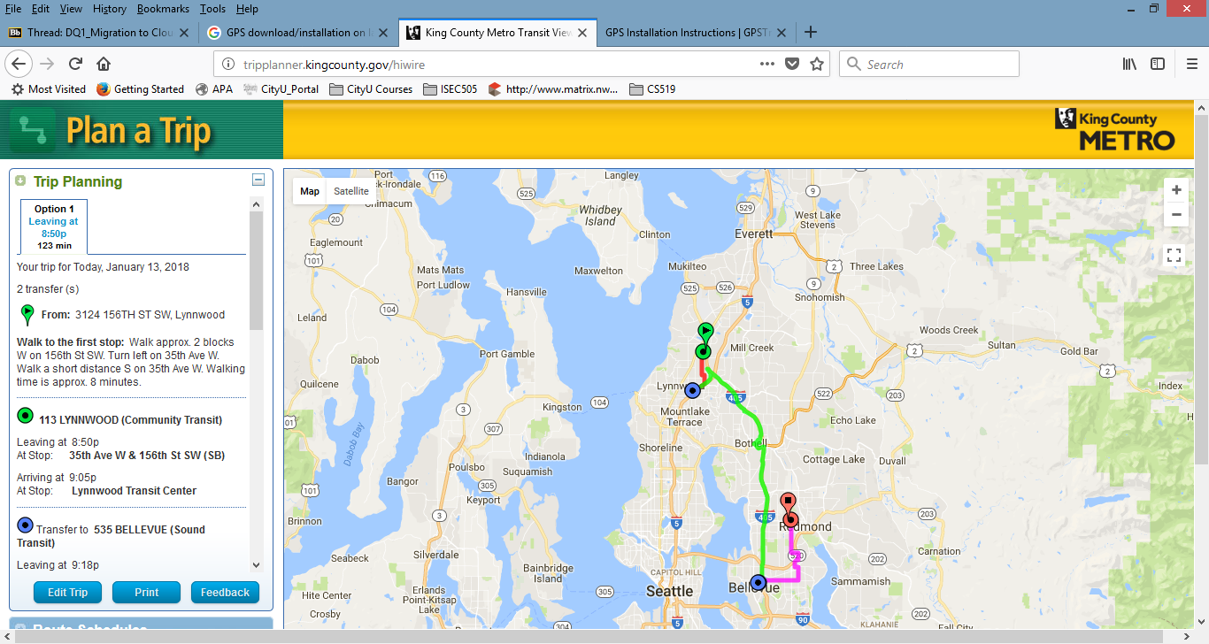

Using the scroll bar on the left pane, below is the the overview summary of all informations the Trip Planner provided. Examples of such informatimation are: Number of Transfer points, Departure time, Arrival time, Adult cash fare, and etc.

Fig: 1.0.8: Shows “Trip Finder” displaying an overview summary of all informations it provided

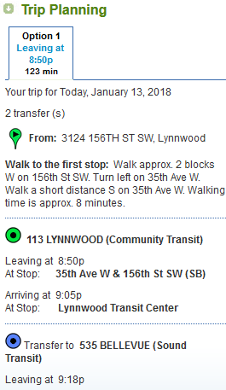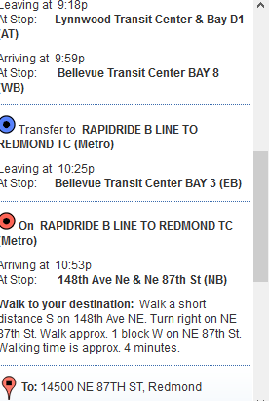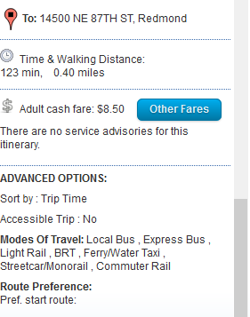

**References:**

https://itstillworks.com/install-gps-laptop-5953847.html

http://tripplanner.kingcounty.gov/